BRAC UNIVERSITY
Department of Computer Science and Engineering

Examination: Semester Final Exam  Duration: 1 Hour 40 Minutes | Semester :Fall 2022  Full Marks: 30
CSE 221: Algorithms

Please add rows as necessary

Graph Theory

Set A
#, Co | Question | Marks
3 | As we all know, the Spanish National Football Team is notorious for their passing football, especially their back passes. After their disastrous 2022 World Cup campaign, The King of Spain made you the coach and declared that no back passes are allowed on the field from now on till Spain scores 2 goals, that is, Simon the goalkeeper can only pass to the defenders Rodri and Cesar, but Rodri and Cesar cannot pass the ball back to Simon. Also, every pass now comes with a cost– and the more cost players accumulate, the angrier the King gets. These are the costs of the passes:  Passes Cost  Simon → Rodri 2  Simon → Cesar 4  Rodri → Cesar 1  Rodri → Pedri 7  Cesar → Gavi 3  Gavi → Pedri 2  Pedri → Morata 1  Gavi → Morata 5  - Find the lowest cost for the ball to reach every player starting from Simon, using any algorithm you find useful. The King will need to see every single step of the algorithm, or he will not believe you and fire you on the spot. | 6
Solution:
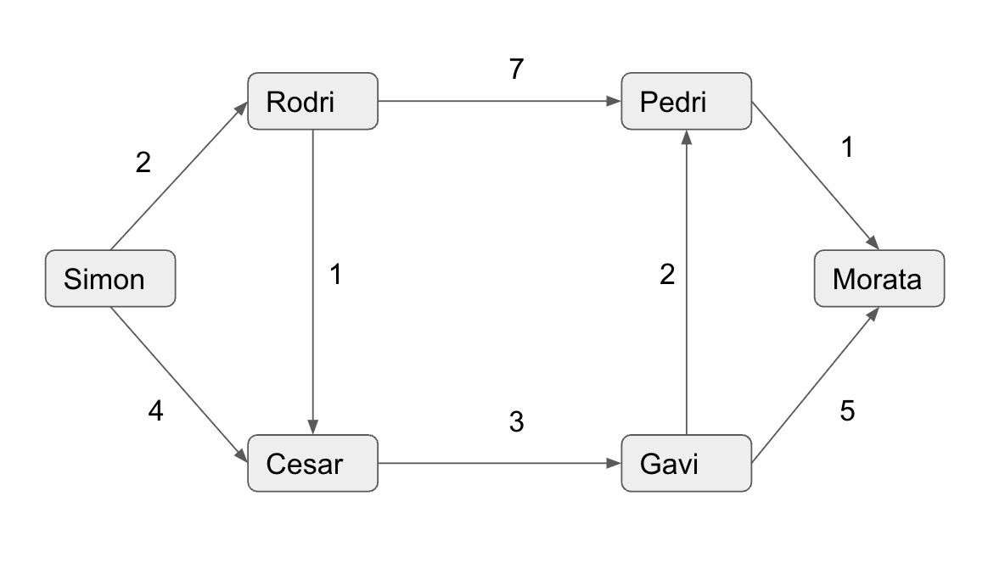
Shortest path algorithm with source: Simon using the path
Simon(0) → Rodri(2) → Cesar(3) → Gavi(6) → Pedri(8) → Morata(9)

Rubrics:
  - Wrote something: 0-1.5 (depending on how wrong they are)
- Wrote Dijkstra but did not show steps or wrote the algorithm in any way: 2.5
- Wrote Dijkstra, showed steps, but made a mistake somewhere: 5
- Full correct: 6
Use your best judgment to deliberate 0.5 marks. For example, if someone wrote the steps for MST, you may give half a mark extra for his or her effort.
3 | After scoring 2 goals, Spain changed their strategy and started to back pass again incorporating 2 more players, the master of dark arts Busquets and the young sensation Ansu Fati. Now they are no longer concerned with the cost of the pass as well. These are the passes for the new strategy:  Passes  Simon → Rodri  Simon → Cesar  Rodri → Busquets  Rodri → Pedri  Cesar → Rodri  Busquets → Gavi  Busquets → Pedri  Gavi → Cesar  Gavi → Pedri  Gavi → Fati  Fati → Morata  Pedri → Fati  Morata → Pedri  - Now using a suitable algorithm find out the largest group of players who can pass the ball among themselves. For example, one such group can be (Fati, Morata, Pedri) where Morata can pass to Pedri, Pedri can pass to Fati and Fati can pass to Morata. It is important to keep in mind that the king will be observing every step of the algorithm. Any discrepancies can lead you to lose your job. | 4
Solution:

S
R
C
B
P
G
F
M
Fig: Initial graph

Top Sorting order: S R B G C P F M

S
R
C
B
P
G
F
M
Fig: transposed graph

Groups: R >>C >>G >> B
P>> M >> F

for gt q1: wrote something: 0.5-1 depending on how wrong they are, wrote dijkstra but did not show steps: 2, wrote dijskta, showed steps but made a mistake somewhere: 3, full correct: 4. 0.5 marks can be deliberated based on your best judgment.

The same goes for SCC.

Set B
#, Co | Question | Marks
3 | As we all know, the Spanish National Football Team is notorious for their passing football, especially their back passes. After their disastrous 2022 World Cup campaign, The King of Spain made you the coach and declared that no back passes are allowed on the field from now on till Spain scores 2 goals, that is, Simon the goalkeeper can only pass to the defenders Rodri and Cesar, but Rodri and Cesar cannot pass the ball back to Simon. Also, every pass now comes with a cost– and the more cost players accumulate, the angrier the King gets. These are the costs of the passes:  Passes Cost  Simon → Cesar 2  Simon → Rodri 4  Cesar → Rodri 1  Rodri → Pedri 3  Cesar → Gavi 7  Pedri → Gavi 2  Pedri → Morata 5  Gavi → Morata 1  - Find the lowest cost for the ball to reach every player starting from Simon, using any algorithm you find useful. The King will need to see every single step of the algorithm, or he will not believe you and fire you on the spot. | 6
Solution:
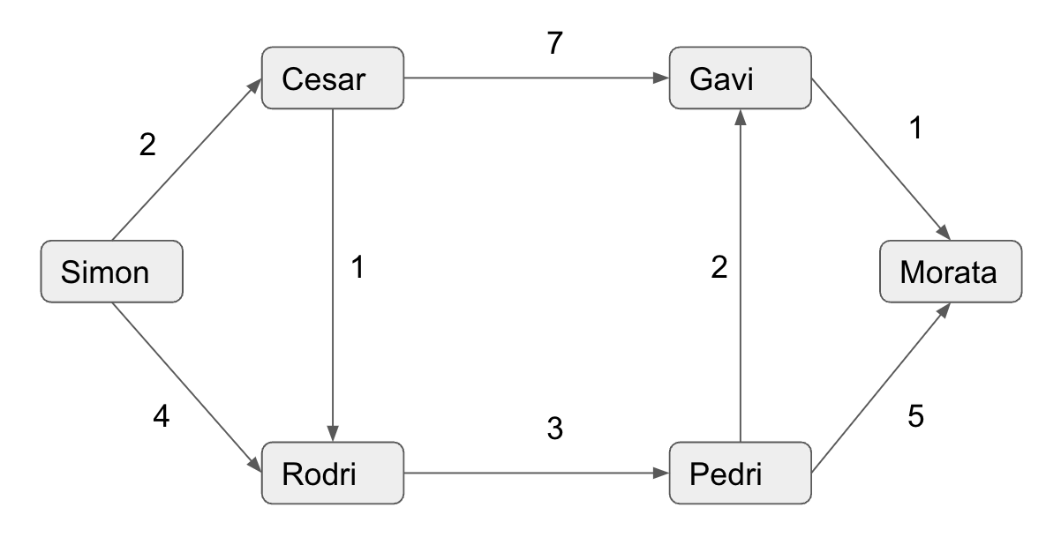
Shortest path algorithm with source: Simon, using the path
Simon(0) → Cesar(2) → Rodri(3) → Pedri(6) → Gavi(8) → Morata(9)

Rubrics:
- Wrote something: 0-1.5 (depending on how wrong they are)
- Wrote Dijkstra but did not show steps or wrote the algorithm in any way: 2.5
- Wrote Dijkstra, showed steps, but made a mistake somewhere: 4
- Full correct: 6
Use your best judgment to deliberate 0.5 marks. For example, if someone wrote the steps for MST, you may give half a mark extra for his or her effort.

3 | After scoring 2 goals, Spain changed their strategy and started to back pass again incorporating 2 more players, the master of dark arts Busquets and the young sensation Ansu Fati. Now they are no longer concerned with the cost of the pass as well. These are the passes for the new strategy:  Passes  Simon → Cesar  Simon → Rodri  Cesar → Gavi  Gavi → Busquets  Gavi → Pedri  Gavi → Fati  Busquets → Pedri  Busquets → Rodri  Pedri → Morata  Fati → Pedri  Morata → Fati  Rodri → Pedri  Rodri → Cesar  - Now using a suitable algorithm find out the largest group of players who will pass the ball among themselves. For example, one such group can be (Fati, Morata, Pedri) where Morata can pass to Fati, Fati can pass to Pedri and Pedri can pass the ball back to Morata. It is important to keep in mind that the king will be observing every step of the algorithm. Any discrepancies can lead you to lose your job. | 4
Solution:

S
R
C
B
P
G
F
M
Fig: Initial graph

Top Sorting order: S R B G C P F M

S
R
C
B
P
G
F
M
Fig: transposed graph

Groups: R >>B >>G >> C ; P>> F >> M

Rubrics | for gt q1: wrote something: 0.5-1 depending on how wrong they are, wrote Dijkstra but did not show steps: 2, wrote dijskta, showed steps but made a mistake somewhere: 3, full correct: 4. 0.5 marks can be deliberated based on your best judgment.  Same goes for SCC.

Greedy

Set A
#, Co | Question | Marks
1 | - You are given the following table containing symbols and their frequencies:  Symbol A B C D +  Frequency 40 10 20 15 15  - Build the Huffman code tree and find the codeword for each character.  - Decode 100010111001010 using the Huffman code that you generated.  - You are given the arrival and departure times of eight trains for a railway platform, each in the following format: $[arrival time, departure time)$. Only one train can use the platform at a time.  Suppose that you have got the following train-use requests for the next day.  $\{ [8, 13), [6, 9), [11, 14), [2, 7), [1, 7), [12, 20), [7, 13) , [13, 20) \}$  i) Find the maximum number of trains that can use the platform without any collision.  ii) Determine the minimum number of platforms necessary to ensure the arrival and departure of all these trains without collision. | [4+1]+[3+2]
Answers | - Huffman Tree  - 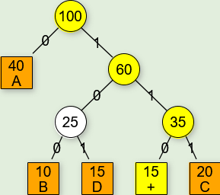  - Decode: BAD+ADA  - Activity Selection  - Total 3 activities selected: $(2, 7), (8, 13), (13, 20)$  - the minimum number of platforms needed to ensure the arrival and departure of all these trains without collision would be 4. A possible solution can be  Platform 1: [(1, 7), (7, 13),(13, 20)]  Platform 2: [(2, 7), (8, 13)]  Platform 3: [(6, 9),(11, 14)]  Platform 4: [(12, 20)]
Rubrics | Huffman Tree:  - Tree Build  - Full Correct: 4  - Partial Correct: Incomplete Tree, Marks can be deliberated based on the examiner’s best judgment.  - Inconsistent Tree: No marks  - Decode  - Based on the tree the student has drawn on the previous question.  Activity Selection Problem  Num. of Platforms(i) and Num. of Groups (ii) Marks  3 Full marks  Not 3 Half Marks  No calculation, only answers Zero Marks

Set B
#, Co | Question | Marks
1 | - You are given the following table containing symbols and their frequencies:  Symbol A B C D #  Frequency 35 15 25 10 20  - Build the Huffman code tree and find the codeword for each character.  - Decode 100010111001010 using the Huffman code that you generated.  - You are given the arrival and departure times of eight trains for a railway platform, each in the following format: $[arrival time, departure time)$. Only one train can use the platform at a time.  Suppose that you have got the following train-use requests for the next day.  $\{ [8, 12), [6, 9), [11, 14), [2, 7), [1, 7), [12, 20), [7, 12) , [13, 19) \}$  i) Find the maximum number of trains that can use the platform without any collision by using.  ii) Determine the minimum number of platforms necessary to ensure the arrival and departure of all these trains without collision. | [4+1]+[3+2]
Answers | - Huffman Tree  - 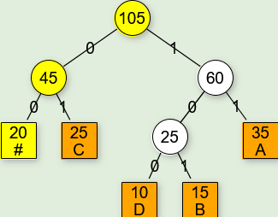  - Decode: DCCA#B  - Activity Selection  - Total 3 activities selected: $(2, 7), (8, 13), (13, 19)$  - the minimum number of platforms needed to ensure the arrival and departure of all these trains without collision would be 3. Possible solution can be  Platform 1: [(1, 7), (7, 12),(12, 20)]  Platform 2: [(2, 7), (8, 12), (13,19)]  Platform 3: [(6, 9),(11, 14)]
Alternate Huffman Answer:
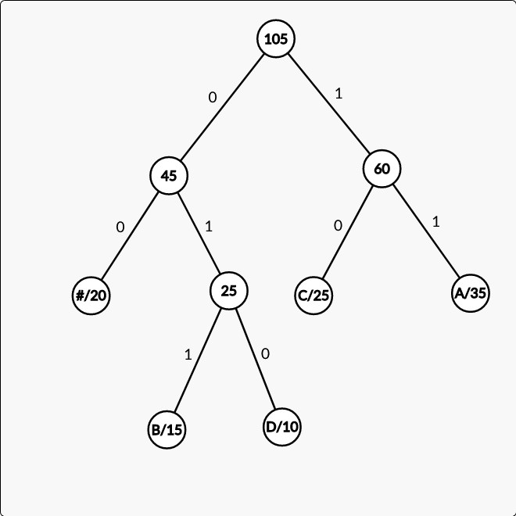
Decode: C#CACDC
Rubrics | Huffman Tree:  - Tree Build  - Full Correct: 4  - Partial Correct: Incomplete Tree, Marks can be deliberated based on the examiner’s best judgment.  - Inconsistent Tree: No marks  - Decode  - Based on the tree the student has drawn on the previous question.  Activity Selection Problem  Num. of Platforms(i) and Num. of Groups (ii) Marks  3 Full marks  Not 3 Half Marks  No calculation, only answers Zero Marks

Brute-force, DP

Set A
#, Co | Question | Marks
1 | Suppose you went to Miniso to buy a Teddy Bear Plushie (a soft toy or doll) as a gift for your younger sister’s birthday. The plushie is 700 BDT. At Miniso, all items are subject to a 6% additional VAT charge.  You bought one plushie and gave the cashier 750 BDT. The cashier has a huge supply of 1 taka, 2 taka, and 5 taka coins in the cashbox. You don’t want to carry many coins, so you asked her to return the change using a minimum number of coins.  - Using the Dynamic Programming approach, determine how many coins she should return in this scenario.  - Which coins did you get from the cashier? Show how your table was used to pick up these coins. You may use arrows and circles to point to the chosen cells.  - Suppose you did not apply memoization to find the answer for question (a). What will be the time complexity of that brute force approach? Explain with proper reasoning.  In question (a), you used dynamic programming techniques via memoization or recursion. How complex will these two strategies be in terms of time, and which strategy will be simpler? Explain using logical reasoning. | 6 + 2 + 2
Answers | - Total Payable: 700 + 6% = 742 BDT  Change: 750 - 742 = 8 BDT  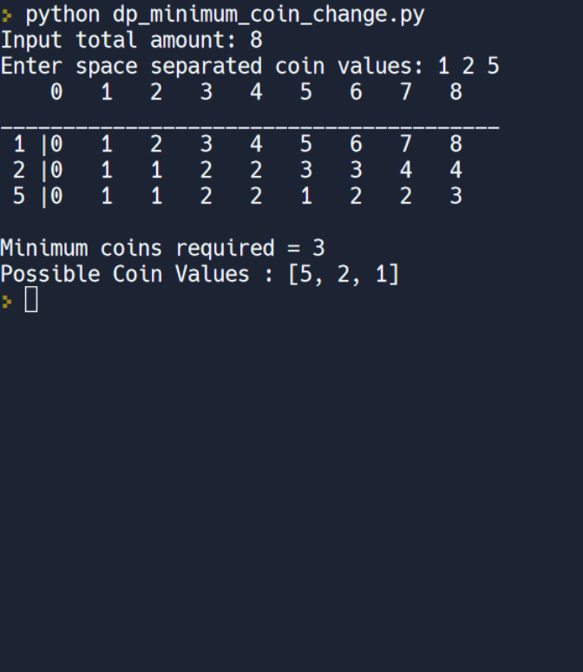
Rubrics | For DP problems, usually no partials are assigned. Because error in one cell is propagated through other cells.  (c) The student should show the proper logic on how memoization is superior in the advantage. Marks can be deliberated based on the examiner’s best judgment.

Set B
#, Co | Question | Marks
1 | A team of two infamous thieves, Denver and Nairobi, planned to rob the famous Louvre Museum. Before the scene, they both agreed on the fact that none of them will break any item as all the items in the Louvre are too precious, and taking a fraction of any item won’t sell in the black market. If it fits in the bag as a whole, they will take it, otherwise, leave it as it is.  Both of them arrived at the Louvre with an empty knapsack weighing a total of 8 kg. Despite the fact that both thieves are experts in their fields, they take slightly different approaches. Denver believes he will use a Dynamic Programming Approach to rob the items in the most efficient manner possible. Nairobi, on the other hand, believes that if she chooses a Greedy Approach, she will make the most money.  The objects in the Louvre Museum are listed below.  Objects Jewelry Sculpture Painting Book Mummy  Profit ($) 5 9 5 4 6  Weight (Kg) 3 5 4 1 12  - What is the maximum profit Denver can make using his strategy? What items did he pick up? Show how Denver used the DP table to select these objects. You may use arrows and circles to point to the chosen cells.  - Does Nairobi’s belief remain valid after the robbery? Prove it. | 6+2+ 2
Answers | - Best value Denver can achieve is 14 $ (Jewelry and Sculpture)  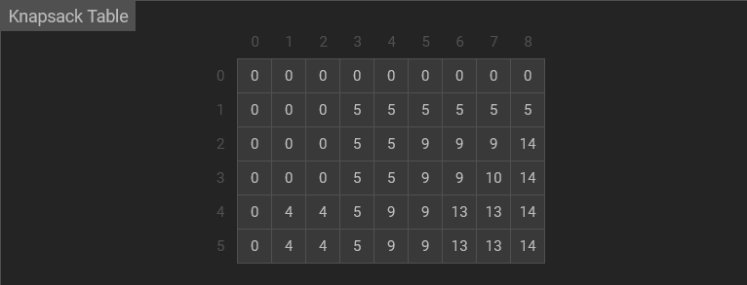  - For Nairobi:  Objects Jewelry Sculpture Painting Book Mummy  $Profit/Weight$ 1.67 1.8 1.25 4 0.5  Weight Remaining Object Taken Object Weight Object Profit  8 Book 1 4  7 Sculpture 5 9  2 No Item can be taken according to thieves’ agreement  Total Profit: 4 + 9 = 13 $  So, No, Nairobi’s belief is not true in this approach.  Even if Nairobi took Jewelry and Sculpture (3 kg + 5 kg = 8 Kg), She couldn’t make more profit than Denver. In this case, her profit would be 14 $ too.
Rubrics | For DP problems, usually no partials are assigned. Because error in one cell is propagated through other cells.

